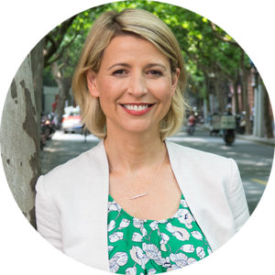

Samantha Brown

Host, PBS’s Samantha Brown’s Places to Love

Travel expert and television host Samantha Brown has been hosting TV travel programs for 20 years. During her time at Travel Channel she created 10 original international and domestic travel series generating over 170 hours of television. In 2017 Samantha moved from the Travel Channel to PBS and Season 1 of her new series Samantha Brown’s Places to Love premiered in January, 2018. In Places to Love, Samantha features the destinations, experiences and most importantly the people that make us the traveler feel like we belong to a place. Season 3 will begin airing on PBS in January 2020 and features destinations like Florida Keys, New Zealand, Miami, Budapest, Dallas and Vienna.

Samantha is known for getting to the emotional heart of travel by focusing on the people, their culture, and the privilege of spending time in their everyday lives. Viewers passionately follow Samantha and her expert advice not only because of her experience and knowledge, but also because of her warmth, genuineness and love for travel.

Samantha grew up in New Hampshire and currently lives in Brooklyn, NY with her husband and 7 year old twins Ellis and Elizabeth.

