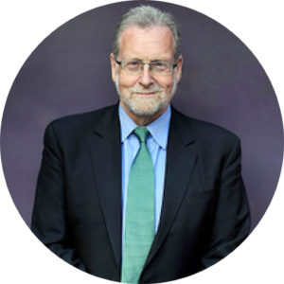

Peter Greenberg

Emmy Award-Winning Investigative Reporter and Producer and CBS News Travel Editor

A multiple Emmy Award-winning investigative reporter and producer, Peter Greenberg is America’s most recognized, honored and respected frontline travel news journalist. He is the Travel Editor for CBS News, appearing on CBS This Morning, the CBS Evening News and CBS Sunday Morning. His long-running nationally syndicated CBS News radio show, Eye on Travel, is broadcast each week from a different location around the world.

The consummate insider on reporting the travel business as news, Greenberg also hosts The Travel Detective, airing on Public Television across the United States. This weekly television newsmagazine offers cutting-edge travel information and insider tips travelers need to know before they ever leave home. It also showcases hidden gem destinations across the country, and around the world.

Greenberg produces and co-hosts an ongoing series of acclaimed global television specials, The Royal Tour, featuring personal, one-on-one journeys through countries with their heads of state. Along with such leaders as the King of Jordan, Prime Ministers of New Zealand and Israel, and Presidents of Mexico and Peru, Greenberg’s latest special features the Prime Minister of Poland.

Greenberg is also author of The New York Times best-selling Travel Detective series. The Best Places for Everything, comes in the wake of such titles as Don’t Go There!, The Complete Travel Detective Bible, Flight Crew Confidential, and The Traveler’s Diet.

Travel Weekly named him one of the most influential people in travel, along with Bill Marriott and Richard Branson. Greenberg was also inducted into the U.S. Travel Association’s Hall of Leaders for his contributions to the travel industry.

Among other honors, Greenberg received a News & Documentary Emmy Award for the ABC 20/20 special, “What Happened to the Children?” Greenberg also won an Emmy as part of the NBC Dateline team for outstanding coverage of a breaking news story, Miracle on the Hudson.

Greenberg began his career in journalism as West Coast correspondent for Newsweek in Los Angeles and San Francisco. He is also the recipient of the Distinguished Service Award in Journalism from the University of Wisconsin, and an Excellence in Broadcasting Award from the Aviation Space Writers Association of America.

His website, PeterGreenberg.com, is one of the leading travel news resources for consumers and industry insiders alike. When he is not traveling the globe, Greenberg also serves as an active volunteer firefighter in New York.

